REF: https://www.w3schools.com/ai/default.asp
If AI was an object it would appear as an onion with layers:
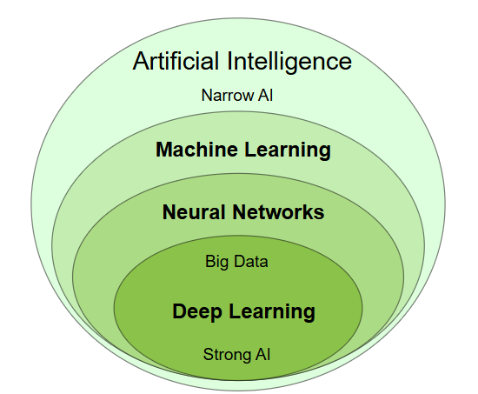

Artificial Intelligence
- Artificial Intelligence is also called Machine Intelligence or Computer Intelligence.
- Artificial Intelligence means making machines mimic humans (Talking, Thinking, Learning, Planning, etc).
- Narrow Artificial Intelligence is limited to narrow (specific) areas [text to speech, Speech recognition, Chatbots, Drones, etc]
- Narrow AI is also called Weak AI.
- Opposite to Weak AI is Strong AI that copies human intelligence.
Machine Learning
- Machine Learning is a subfield of Artificial Intelligence.
Traditional Programming (uses Algo) | Machine Learning (creates Algo)
Data + Algorithm = Result | Data + Result = Algorithm

- Traditionally, Machine Learning applications are using mostly R or Python languages.
- Some terminologies in Machine Learning(ML):
  - Relationships: Used between inputs to produce predictions.
  - Label: The thing you want to predict
  - Features: Input
- There are 3 types of Machine Learning:
  - Supervised Machine Learning: Learn from set of inputs
  - Unsupervised Machine Learning: Try to understand patterns
  - Self-Supervised Machine Learning: Same as unsupervised but draw its own conclusions
- Upto 80% of Machine Learning project is about Collecting Data (data is collection of facts).
- Clusters are collections of data based on similarity.
- Some of the famous langauges for programming in Machine Learning are LISP, Python, C++, etc.
- Machine Learning(ML) has found its way into JavaScript with which developers can add Machine Learning and Artificial Intelligence to web applications.
- Some popular JavaScript libraries are Brain.js, Math.js, ml5.js, d3.js, etc.

Neural Networks
- Neural Networks is a programming technique used in machine learning.
- Neural Networks are based on how the human brain works.

- Machine Learning and Artificial Intelligence to web applications.
- Some popular JavaScript libraries are Brain.js, Math.js, ml5.js, d3.js, etc.

sad

